Fleet management VBCS page

1. Search Page…………………………………

2. Details Page………………………………...

3. Edit Page…………………………………….

4. Create Contract Page…………………

5. Renew Contract Page…………………

Fleet Management VBCS Application
The Fleet Management application is designed to streamline vehicle and contract management processes. It consists of five key pages, each serving a specific purpose in the vehicle and contract lifecycle.

1. Search Page
- Purpose: Acts as the main entry point for users to search and view fleet records.
- Functionality:
  - Allows users to search vehicles or contracts using filters such as vehicle number, contract number, or customer name.
  - Displays search results in a structured table format with key details (e.g., vehicle, contract status, and validity).
  - Provides navigation options to view details, edit, or create new records.

2. Details Page
- Purpose: Displays comprehensive information about a selected vehicle or contract.
- Functionality:
  - Shows all relevant data such as vehicle information, contract terms, start and end dates, and associated customer details.
  - Read-only view for users to review all attributes before making changes.
  - Includes action buttons for navigation to the Edit or Renew pages.

3. Edit Page
- Purpose: Allows users to modify existing vehicle or contract details.
- Functionality:
  - Enables editing of editable fields such as contract duration, vehicle status, or customer details.
  - Includes form validations to ensure data accuracy.
  - Updates the record in the system upon successful submission.

4. Create Contract Page
- Purpose: Facilitates the creation of new contracts for vehicles in the fleet.
- Functionality:
  - Provides a structured form to capture contract details such as contract number, start and end dates, customer information, and associated vehicle.
  - Includes mandatory field validation and user guidance messages.
  - Submits data to the backend to create a new contract record.

5. Renew Contract Page
- Purpose: Enables users to renew existing contracts that are nearing expiry.
- Functionality:
  - Prefills existing contract details for convenience.
  - Allows updating of renewal-specific information such as new contract duration, revised terms, or pricing.
  - Creates a new renewal record while maintaining linkage to the original contract.

Data Store
All Fleet Management-related data within the application is managed and stored in a dedicated Business Object (BO) in Oracle Visual Builder.
This Business Object serves as the central data repository for the Fleet Management module, capturing and maintaining records for all core operations such as vehicle details, contracts, renewals, and unassignments.
Whenever a user performs actions like creating, editing, renewing, or unassigning a vehicle contract, the corresponding data is automatically saved, updated, or deleted within this Business Object.
This ensures that:
- All Fleet Management data is stored in a structured and consistent format.
- The application can easily retrieve and display records across different pages (Search, Edit, Create, Renew).
- Data integrity and synchronization are maintained across the entire module.

1. Search Page
Using the combo box component
A Combo Box in VBCS is a hybrid input control that combines:
- a text input field (where users can type to filter or search values), and
- a dropdown list (showing selectable options).
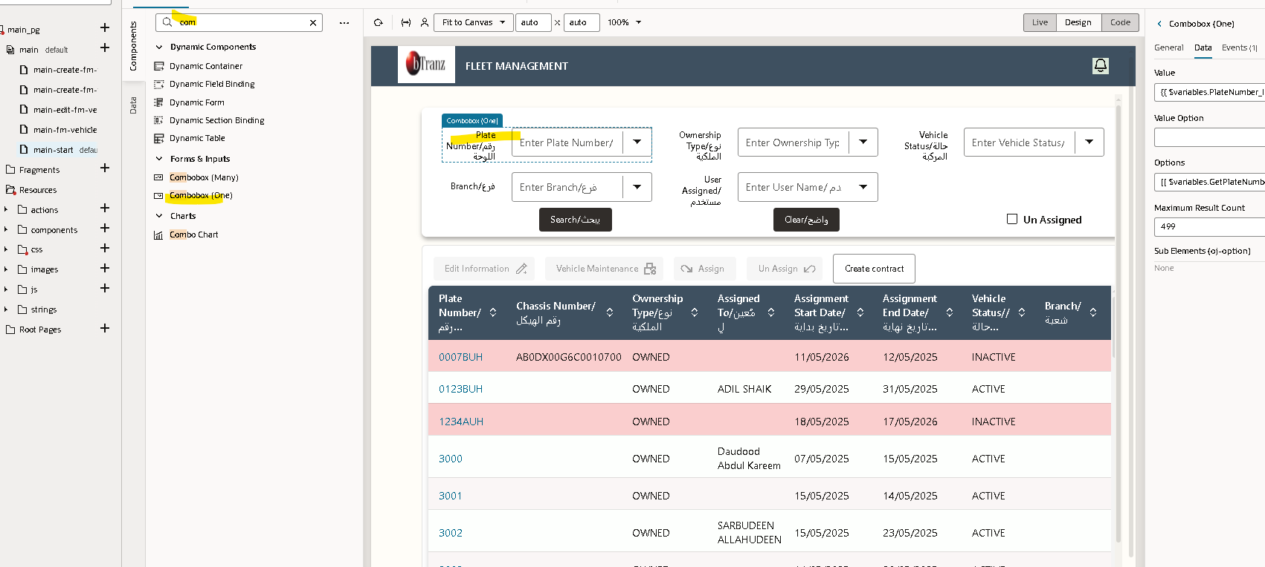
Using the table component
A Table component in VBCS is a data-driven UI control that displays a collection of records (rows), with each field represented as a column.
It’s ideal for presenting data from Business Objects, REST APIs, or Variables.
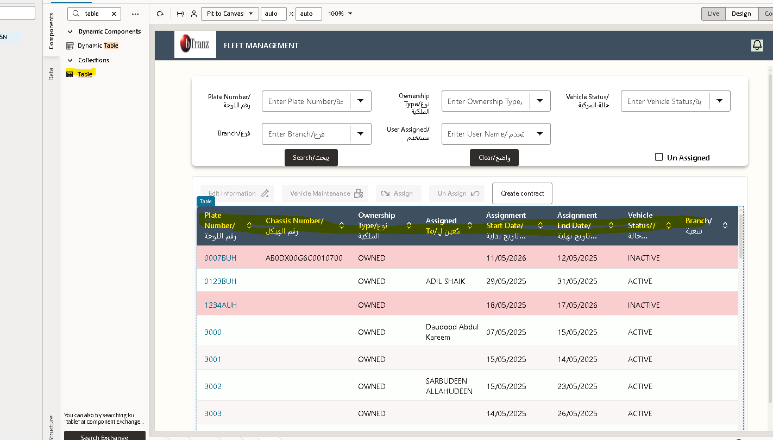
Defined the table labels in the DATA .
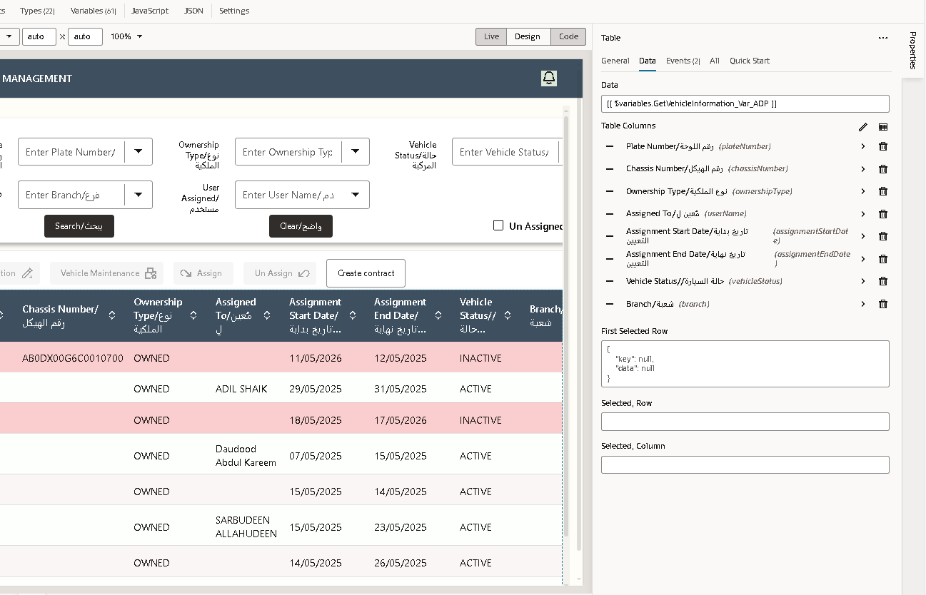
Using the Hyperlink
A Hyperlink is a UI component used to navigate to another page, external website, or trigger an action when clicked — similar to a web link on any standard webpage.
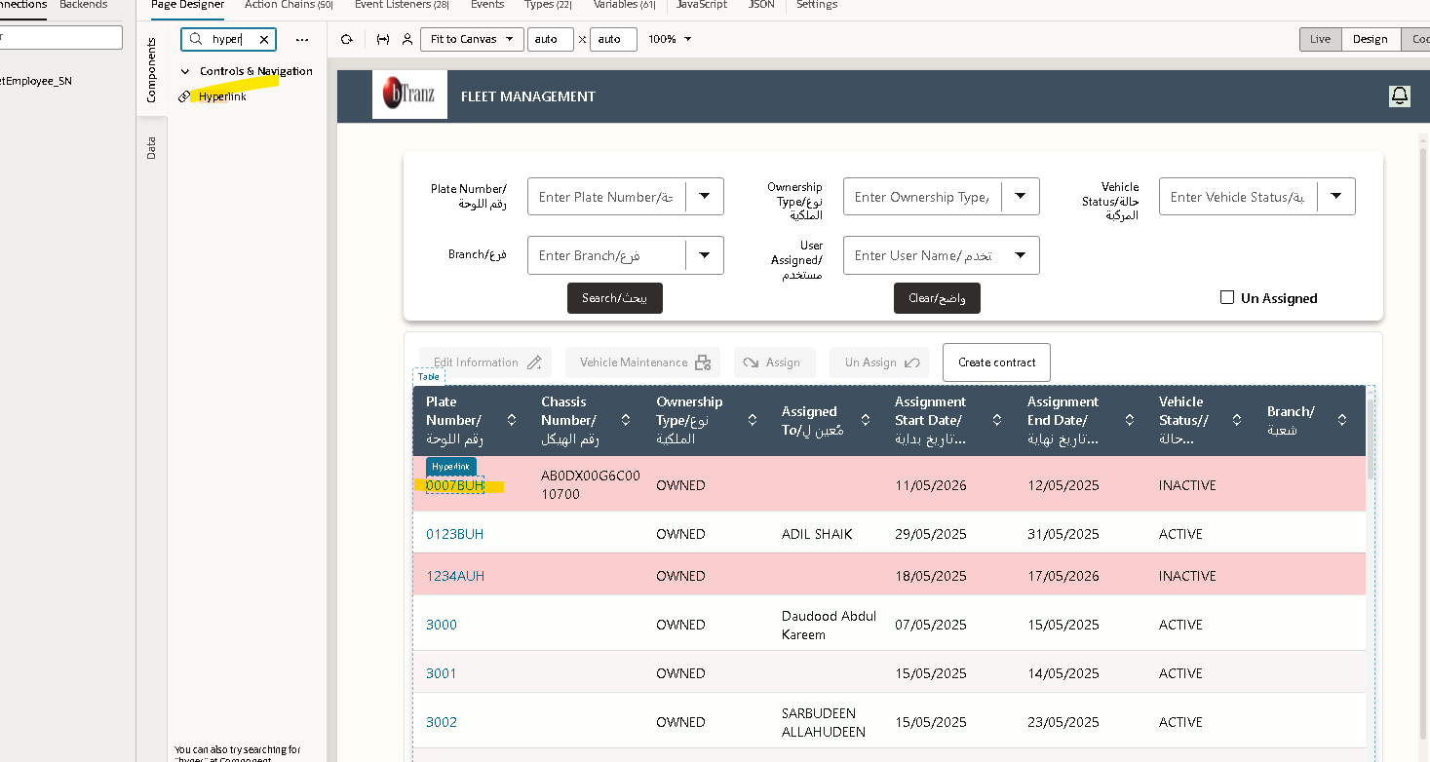
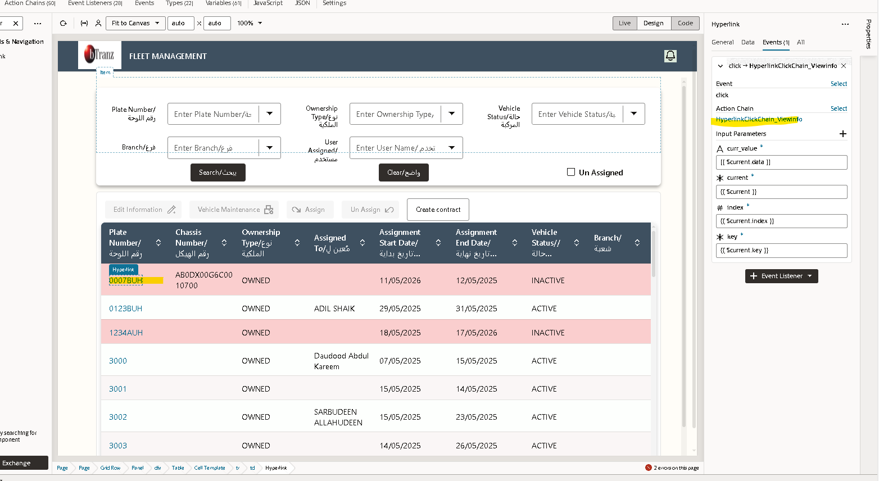
By clicking on this hyperlink we will navigate to the details page
We have a action chain called View info
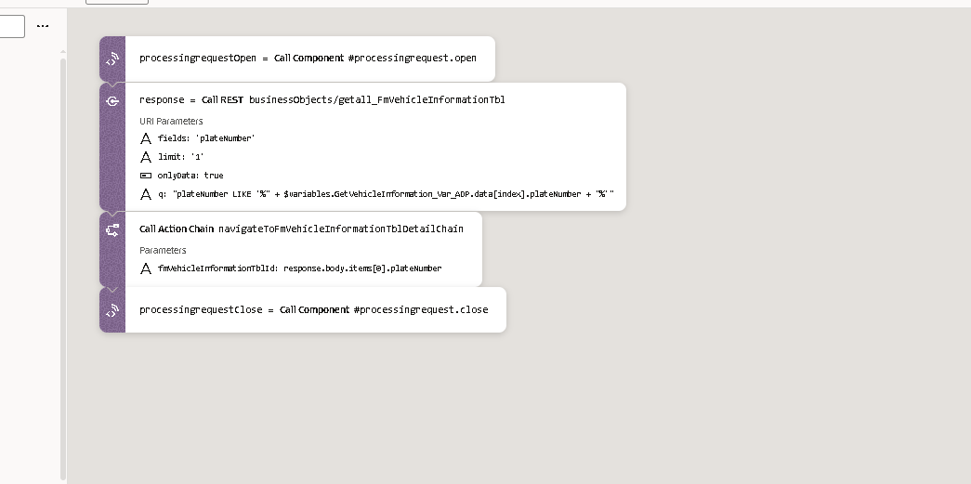
This hyperlink Action Chain is designed to:
- Fetch vehicle details from the Business Object using the vehicle’s plate number, and then
- Navigate to the Vehicle Details Page with that specific record’s information.
So when a user clicks the hyperlink (e.g., “View Details”), this action chain runs in the background.

Step-by-Step Explanation

1.processingrequestOpen = CallComponent #processingrequest.open
- This step opens a processing indicator (like a spinner or loading icon).
- It visually indicates to the user that the system is fetching data.
- It improves user experience by showing that a request is in progress.
In simple terms:
“Show the loading animation before starting the API call.”

2.response = CallREST businessObjects/getall_FmVehicleInformationTbl
- This step calls the REST endpoint of your Business Object named FmVehicleInformationTbl.
- It retrieves data based on the plate number entered or selected.
Parameters used:
- fields: 'plateNumber' → Only fetches this field from the record.
- limit: '1' → Fetches only one record (first matching record).
- onlyData: true → Returns only the data section of the response.

3.Call ActionChain navigateToFmVehicleInformationTblDetailChain
- Once the API successfully returns data, this step navigates to the Details Page.
- It passes the plate number from the fetched record as a parameter.

processingrequestClose = Call Component #processingrequest.close
- After the navigation action, the processing indicator (spinner) is turned off.
- This step ensures the UI returns to normal after the operation completes.
- In simple terms:
“Hide the loading animation once the operation is complete.”
Creating the button
For search where it will fetch all the data
And to clear the data where it will clear the data which you have searched
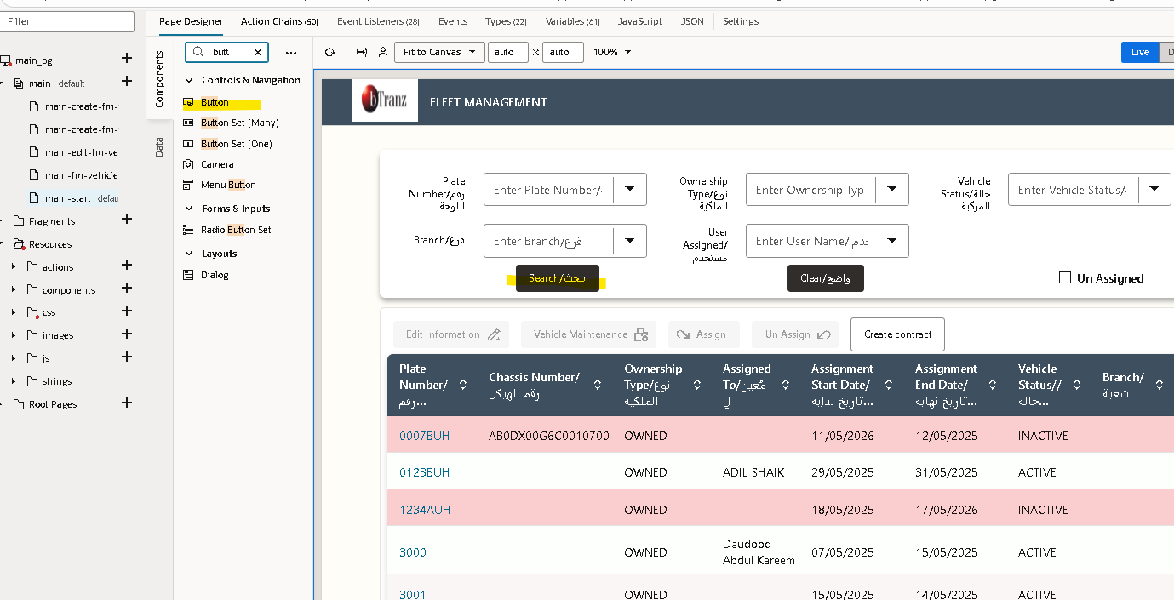
Using the buttons to assign and un assign

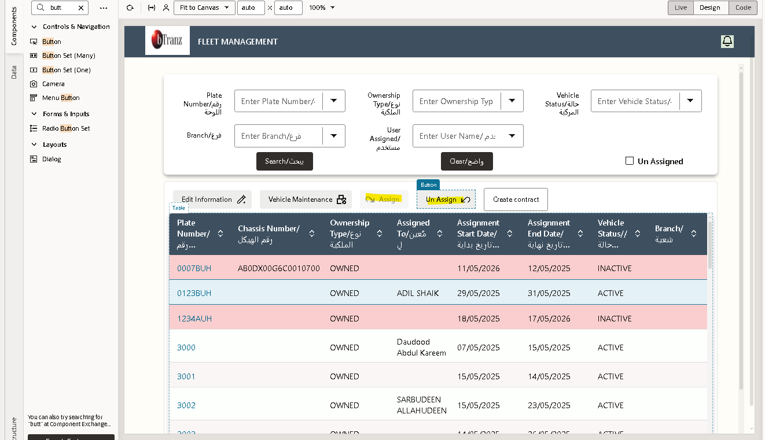
Click on action chain
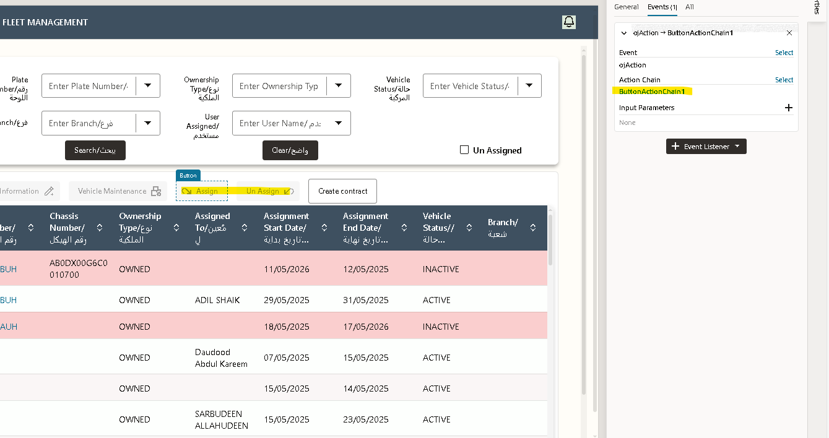
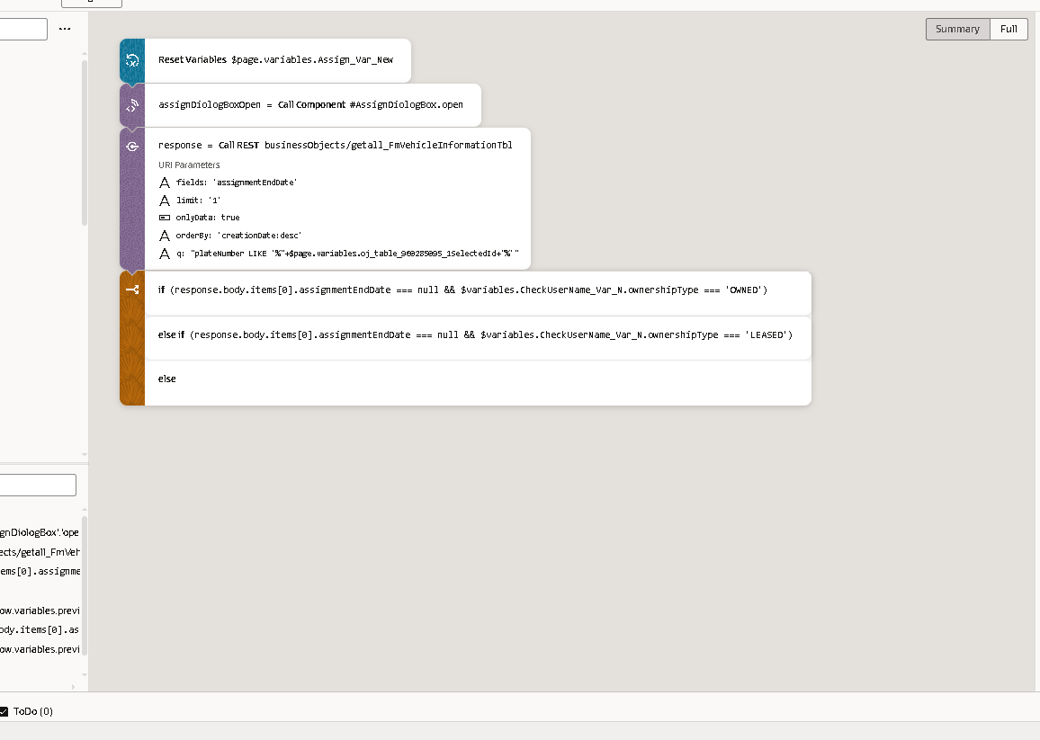
This event initializes the vehicle assignment process by resetting temporary variables, opening the assignment dialog box, and validating vehicle assignment status via a REST call. Based on the ownership type (‘Owned’ or ‘Leased’) and the assignment end date, it determines whether a new assignment can proceed.

Step 1 – Reset Variables
Action:
Reset Variables $page.variables.Assign_Var_New

Step 2 – Open Assignment Dialog Box
Action:
assignDialogBoxOpen = Call Component #assignDialogBox.open
Description:
This action opens the vehicle assignment dialog box component on the page.
The dialog box allows the user to enter or view assignment details (for example, employee name, assignment date, vehicle number, etc.).
It serves as the user interface for adding or editing vehicle assignment information.

Step 3 – Call REST Service
Action:
response = CallREST businessObjects/getall_FmVehicleInformationTbl
Description:
This step calls a REST API or a Business Object endpoint (getall_FmVehicleInformationTbl) to retrieve information related to the selected vehicle.
The parameters configured in this REST call are:
Parameter | Value / Purpose
fields | assignmentEndDate – fetches the assignment end date field for validation.
limit | 1 – retrieves only the most recent record.
onlyData | true – ensures that only the data portion of the response is returned.
orderBy | creationDate:desc – sorts the records by creation date in descending order (latest first).
q | plateNumber LIKE "%<selected plate number>%" – filters data for the selected vehicle’s plate number.
Purpose:
This step helps check whether the selected vehicle is already assigned to someone (by checking if the assignmentEndDate is null) and retrieves ownership details before creating a new assignment.

Step 4 – Conditional Checks

Condition 1: Vehicle Owned and Still Assigned
Code:
if (response.body.items[0].assignmentEndDate === null && $variables.checkUserName_Var_N.ownershipType === 'OWNED')
Explanation:
If the assignmentEndDate is null, it means the vehicle is currently assigned.
At the same time, if the ownership type is ‘OWNED’, this condition prevents the system from assigning it again.
Usually, this branch is used to show a validation message such as:
“This vehicle is already assigned. Please end the current assignment before assigning it again.”

Condition 2: Vehicle Leased and Still Assigned
Code:
elseif (response.body.items[0].assignmentEndDate === null && $variables.checkUserName_Var_N.ownershipType === 'LEASED')
Explanation:
If the vehicle is leased and also has no assignmentEndDate, it indicates an active assignment under lease.
This condition applies a different business rule — for example, allowing limited reassignment under lease or prompting a different message like:
“This leased vehicle is already in use.”

Condition 3: Else Condition
Code:
else
Explanation:
If neither of the above conditions are true, it means:
- The vehicle has an assignment end date (it’s available), or
- There is no previous assignment record.
In this case, the logic proceeds with a new assignment creation process or allows the user to enter new details in the dialog box.

Step 5 – Purpose of the Complete Flow
Overall Description:
This event automates the vehicle assignment validation and setup process in the Fleet Management module.
It ensures that:
- Variables are reset before every assignment.
- The assignment dialog box opens correctly.
- The system checks vehicle availability and ownership status before allowing reassignment.
This prevents duplicate vehicle assignments and enforces business rules for both Owned and Leased vehicles.
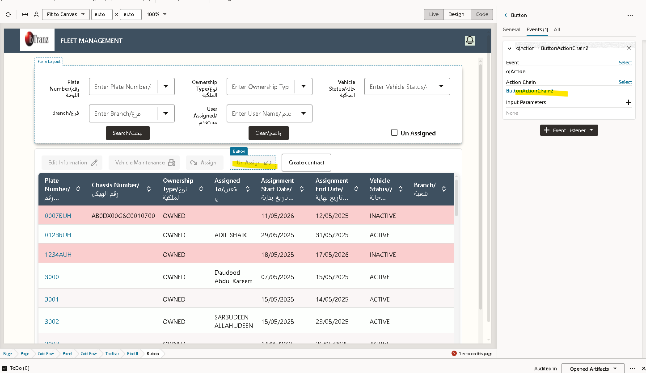
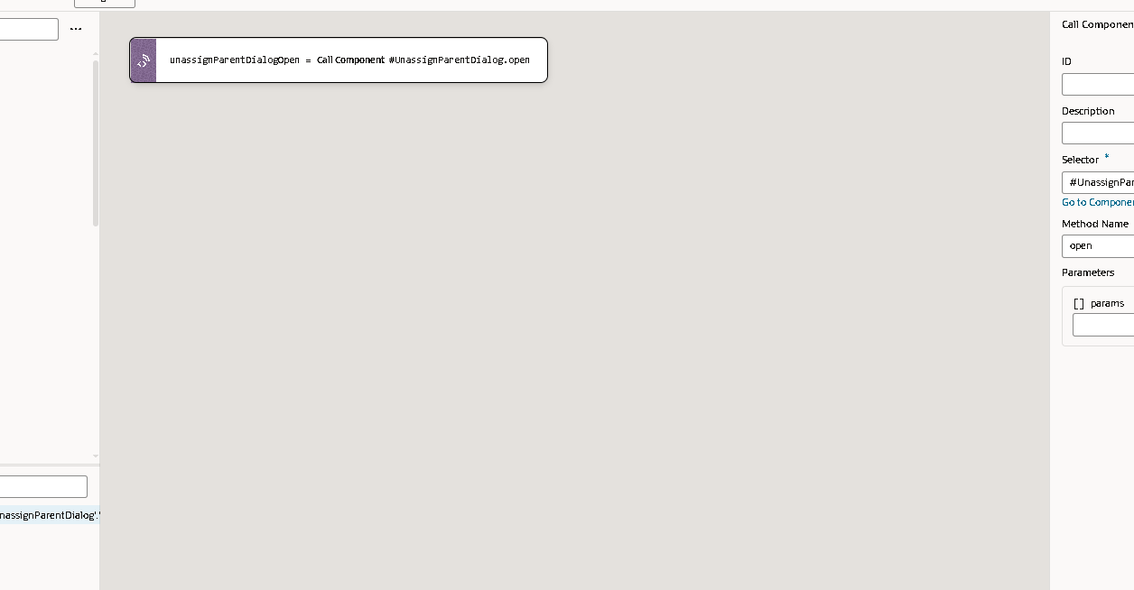

Event: Unassign Parent Dialog Open (Unassign Vehicle Event)

Purpose:
This event is used to initiate the vehicle unassignment process in the Fleet Management application.
When a user selects a vehicle or record to unassign, this event opens the Unassign Parent Dialog box, where the user can confirm and perform the unassignment action.

Step-by-Step Explanation:

1. Action: Call Component
UnassignParentDialogOpen = CallComponent #UnassignParentDialog.open
Description:
- This action calls the UnassignParentDialog component and executes its open method.
- The dialog box named UnassignParentDialog is a reusable UI component designed to handle the vehicle unassignment confirmation process.

The Unassign Vehicle event ensures that a vehicle currently assigned to an employee can be released (unassigned) properly.
It acts as the first step in the unassignment workflow by presenting a confirmation dialog before making any database or REST API updates.
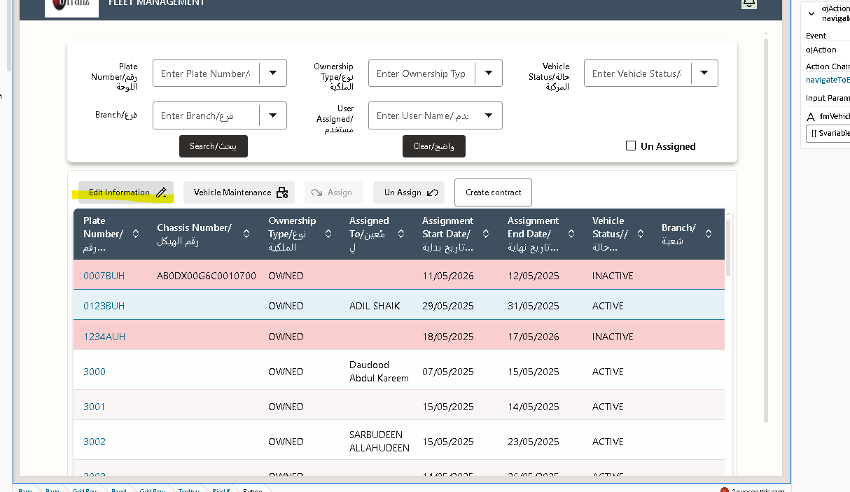
Click on edit in formation page if you want to edit the data

Edit Page
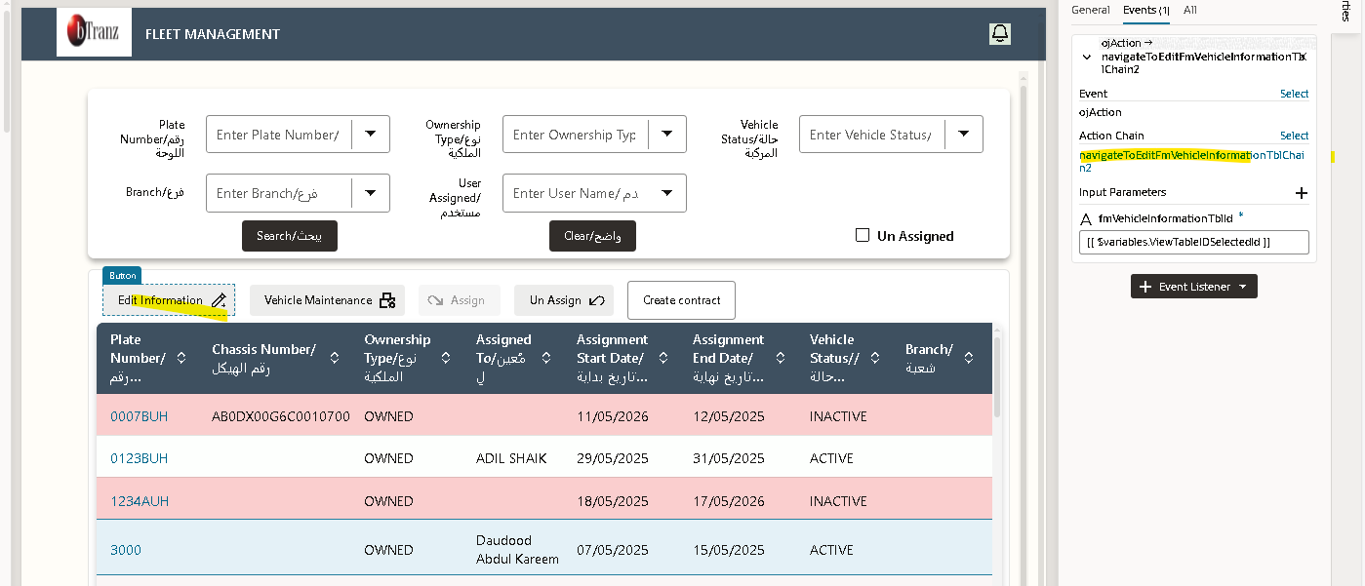
Go to the event
This event is triggered when the user clicks the Edit button for a vehicle record.
It opens a processing loader, navigates to the Edit Vehicle Information page, and then closes the loader once navigation is complete.
- Step 1 – Call Component: processingrequest.open
- processingrequestOpen2 = Call Component #processingrequest.open
  - This step triggers the Processing Request component to open.
  - It usually displays a loading spinner or “Processing…” popup to indicate that the system is performing an operation.
  - This improves user experience by preventing duplicate clicks and showing that the action is being processed.

- Step 2 – Navigate to Edit Page
- navigateToPageMainEditFmVehicleInformationTblResult =
- Navigate To Page main-edit-fm-vehicle-information-tbl
- Parameters:
- fmVehicleInformationTblId: fmVehicleInformationTblId
  - This step navigates the user to the Edit Vehicle Information page (main-edit-fm-vehicle-information-tbl).
  - It passes the selected vehicle’s ID (fmVehicleInformationTblId) as a parameter, so that the edit page can load that specific vehicle’s data.
  - In simple terms — when the user clicks Edit, the system opens the vehicle record in edit mode using its ID.

- Step 3 – Call Component: processingrequest.close
- processingrequestClose = Call Component #processingrequest.close
  - After navigation, this step closes the Processing Request component.
  - This hides the loading popup and indicates that the navigation process has completed.
- The system first opens a processing request component to show a loading indicator.
- It then navigates to the Edit Vehicle Information page (main-edit-fm-vehicle-information-tbl) and passes the selected vehicle’s ID (fmVehicleInformationTblId) as a parameter.
- Once the navigation is complete, the processing request component closes to end the loading process.
Purpose:
To ensure smooth navigation and provide a clear user experience when opening a vehicle record for editing.

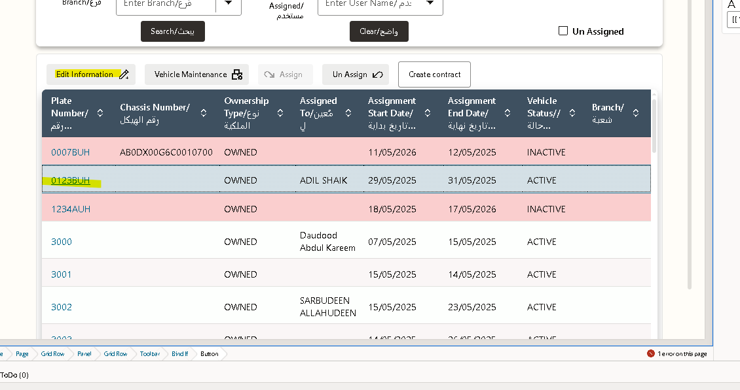
Select the data which you want to edit
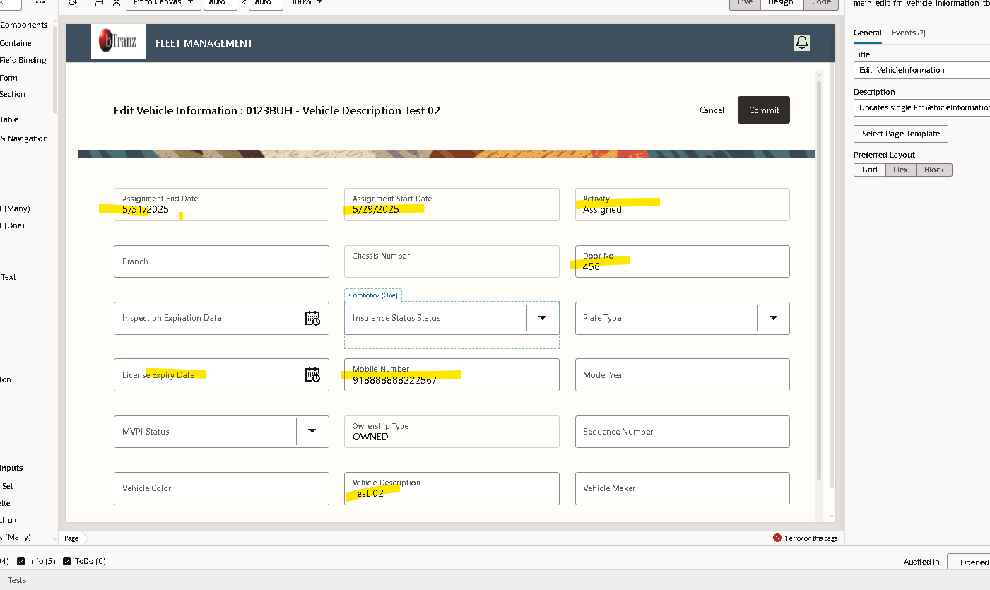
Edit the information
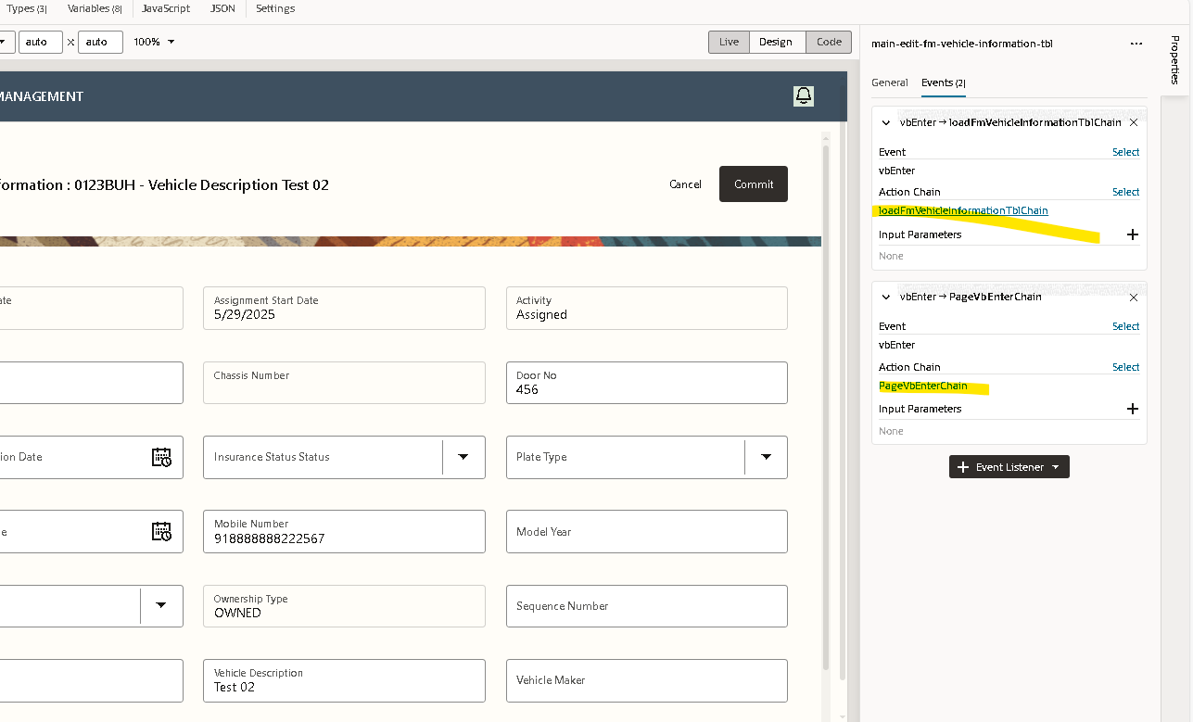
Go to the events of this edit page

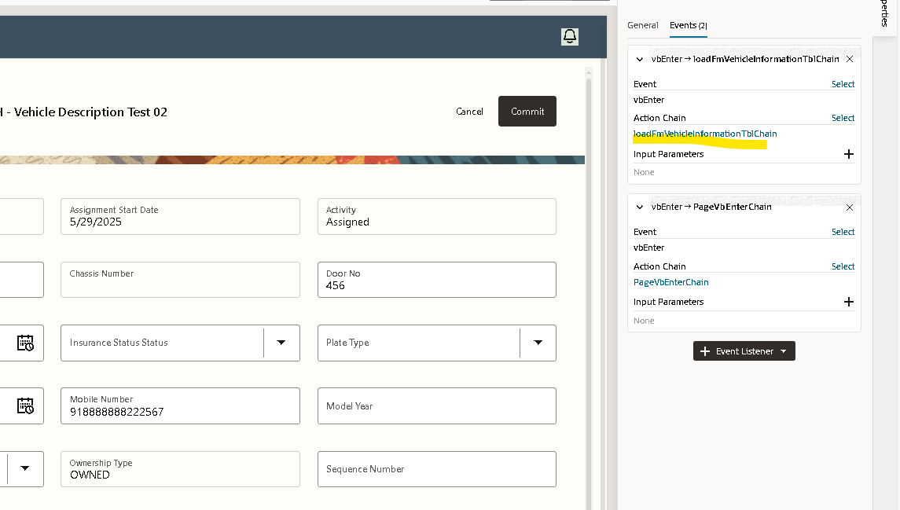 1.Call REST Service
Action:
callRestResult = CallREST businessObjects/get_FmVehicleInformationTbl
Description:
This step triggers a REST API call to retrieve detailed information about the selected vehicle from the FmVehicleInformationTbl business object.
Parameters Passed:
Parameter | Value / Purpose
FmVehicleInformationTbl_Id | $page.variables.fmVehicleInformationTblId → the ID of the selected vehicle record.
responseType | 'getFmVehicleInformationTblResponse' → expected response type.
Purpose:
Fetches the detailed information of a particular vehicle based on its ID so that the data can be displayed on the

2.Error Handling
Condition:
if (!callRestResult.ok)
Description:
This condition checks whether the REST API call executed successfully.
If the call failed (for example, due to network error, missing data, or server issue), the following steps are executed:

3.Create Error Message
errorMessage = callRestResult.body?.detail || callRestResult.body?.['o:errorDetails']?.[0]?.detail || `Could not load data: status ${callRestResult.status}`
Description:
- The system creates a meaningful error message to describe what went wrong.
- It first tries to extract the error details from the API response (detail or o:errorDetails), and if not available, it falls back to a general message with the HTTP status code.

4. Fire Notification (Error Alert)
Fire Notification: Could not load data
Parameters: message = errorMessage
Description:
This step displays a notification to the user indicating that the system failed to load data.
The message content is taken from the errorMessage variable created in the previous step.
For example:
“Could not load data: status 404”
or
“Vehicle record not found.”

5.Return
If an error occurs, the Action Chain stops executing further steps.
This ensures that no invalid data is processed or displayed on the Edit Page.

6.Assign Response Data to Page Variables
If the REST API call was successful, the next three actions execute:
$page.variables.fetchedFmVehicleInformationTbl = callRestResult.body
$page.variables.fmVehicleInformationTbl = $page.variables.fetchedFmVehicleInformationTbl
$page.variables.fmVehicleInformationTblETag = callRestResult.headers.get('ETag')
Explanation:
Variable | Purpose
fetchedFmVehicleInformationTbl | Stores the fetched data returned by the REST API.
fmVehicleInformationTbl | Assigns the same data to another variable used for data binding on the edit page (e.g., form fields).
fmVehicleInformationTblETag | Stores the ETag header value from the REST response — this is used for optimistic locking during updates (ensures that data has not changed since it was fetched).

7.Summary of Flow
Step | Action | Purpose
1 | Call REST | Fetch vehicle information from backend.
2 | If condition | Check if data retrieval was successful.
3 | Create Error Message | Prepare an error message if data fetch fails.
4 | Fire Notification | Display an alert to user on failure.
5 | Return | Stop execution if failed.
6 | Assign Variables | Store API response and ETag for use in the edit page.

This event fetches the selected vehicle’s information for editing, manages errors gracefully, and prepares the data for display on the Edit Vehicle page in the Fleet Management system.
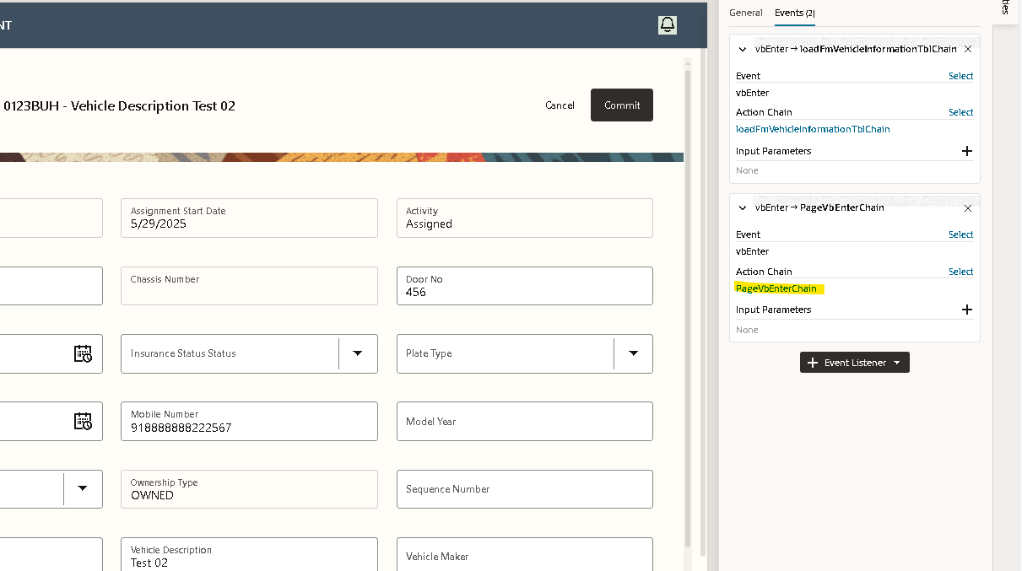
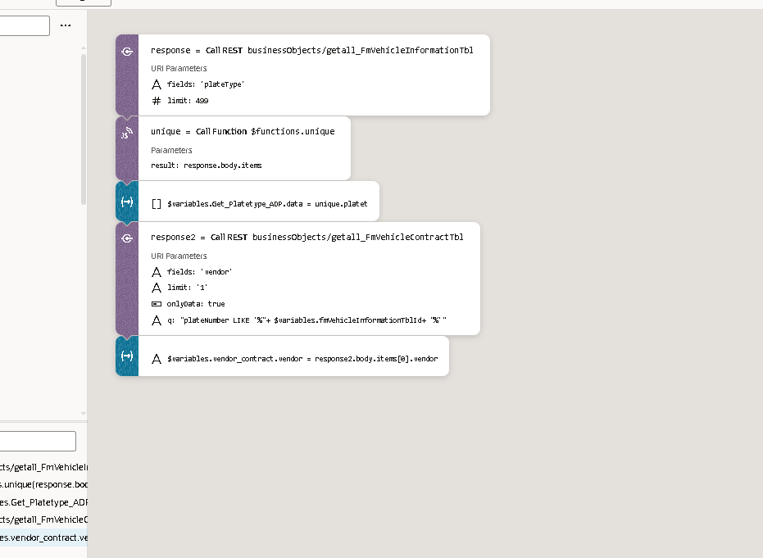

Event 2: Save or Update Vehicle Information (Edit Page)

Purpose:
This event is triggered when the user clicks the “Save” or “Update” button on the Edit Vehicle Page.
It updates the selected vehicle record in the database (Business Object FmVehicleInformationTbl) with the modified details entered by the user.

Step-by-Step Explanation:

1.Call REST Service – Update Vehicle Information
Action:
callRestUpdate = CallREST businessObjects/patch_FmVehicleInformationTbl
Description:
This REST call updates the vehicle record in the backend Business Object using the PATCH method.
It sends the modified details from the page variables to the server.
Parameters:
Parameter | Value / Description
FmVehicleInformationTbl_Id | $page.variables.fmVehicleInformationTblId – the ID of the vehicle being edited.
body | $page.variables.fmVehicleInformationTbl – the updated data entered by the user on the page.
If-Match | $page.variables.fmVehicleInformationTblETag – ensures data integrity (optimistic locking).
Purpose:
This step pushes all modified data (like vehicle type, plate number, assignment, or status) back to the database.

2.Check Response for Success or Failure
Condition:
if (!callRestUpdate.ok)
Explanation:
This condition checks if the REST update request executed successfully.
If the update fails (for example, due to validation errors, concurrent updates, or connectivity issues), the system performs the following error-handling steps.

3.Create Error Message
Action:
errorMessage = callRestUpdate.body?.detail || `Failed to update record: status ${callRestUpdate.status}`
Description:
This creates an error message from the REST API response or builds a generic message using the HTTP status code if no detailed error is returned.

4.Fire Notification – Error Message
Action:
Fire Notification: "Failed to update record"
Parameters: message = errorMessage
Description:
Displays an error notification on the page to inform the user that the update action could not be completed successfully.

5.Return
Description:
Stops the action chain execution to prevent further processing when the update fails.

6.On Success – Fire Notification
Action:
Fire Notification: "Vehicle information updated successfully"
Description:
If the REST call succeeds, this message confirms that the vehicle details were updated successfully in the system.

7.Navigate or Refresh
After a successful update, the system may:
- Navigate back to the Vehicle Details page or Search page, or
- Refresh the current data table to show updated information.
Typical example:
Navigate to Page: FleetVehicleList

Summary of Flow
Step | Action | Purpose
1 | Call REST (PATCH) | Update the selected vehicle record in the backend.
2 | If Condition | Verify if the REST call succeeded.
3 | Create Error Message | Prepare message in case of failure.
4 | Fire Notification (Error) | Notify user if update fails.
5 | Return | Stop flow on failure.
6 | Fire Notification (Success) | Confirm successful update to user.
7 | Navigate or Refresh | Redirect or refresh page to show updated info.

Scroll down on the page
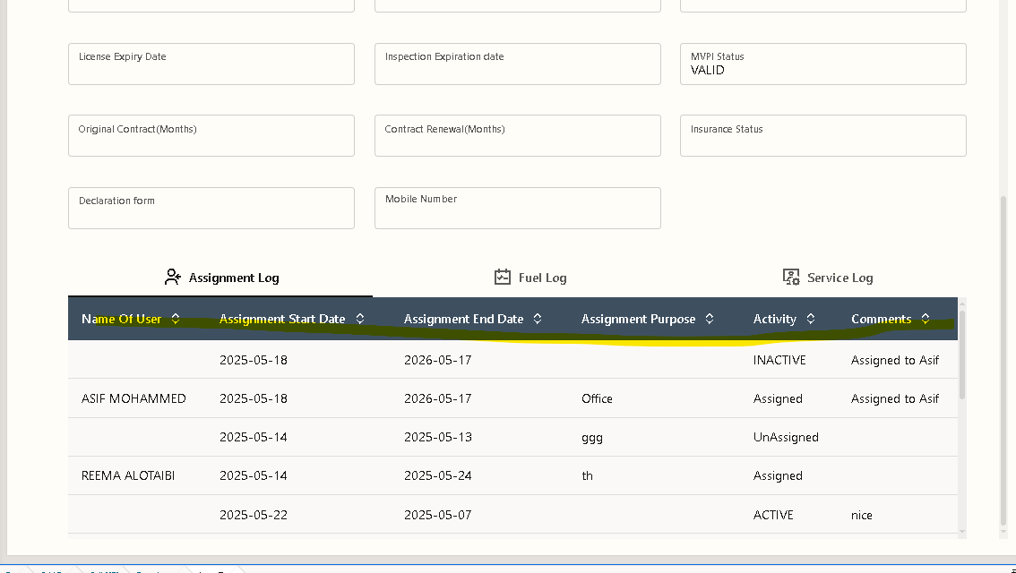
  - Assignment Log .
  - Fuel Log.
  - Service Log.
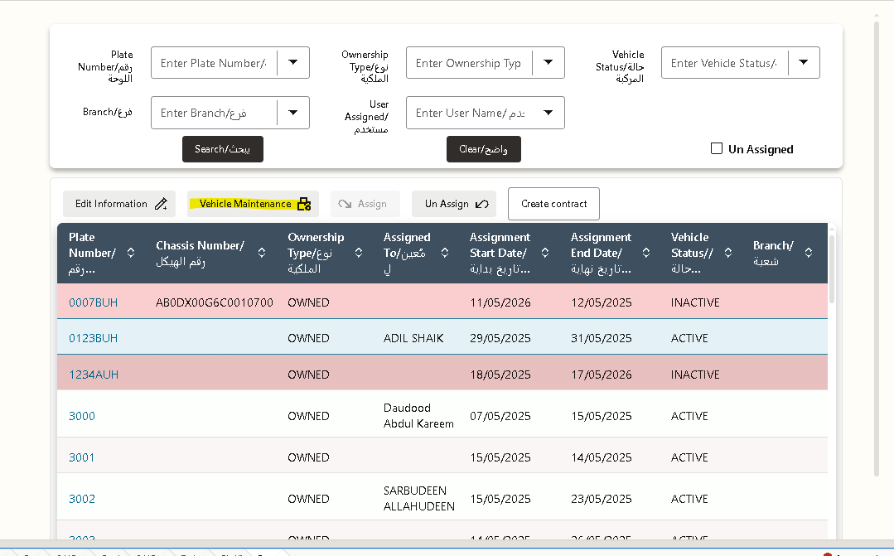

Click on vehicle maintenance
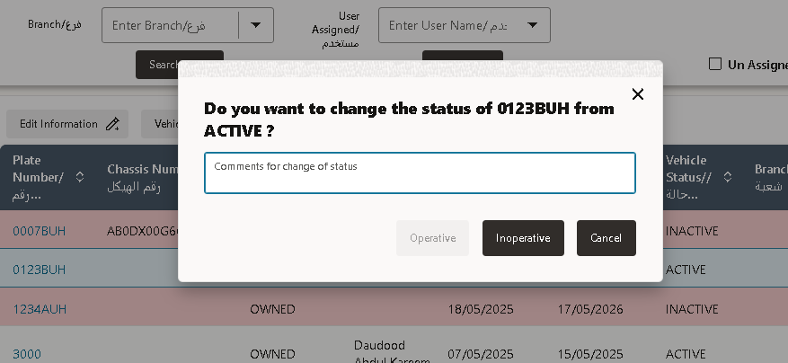
You can change the status of the particular plate number from this

Create Contract Page
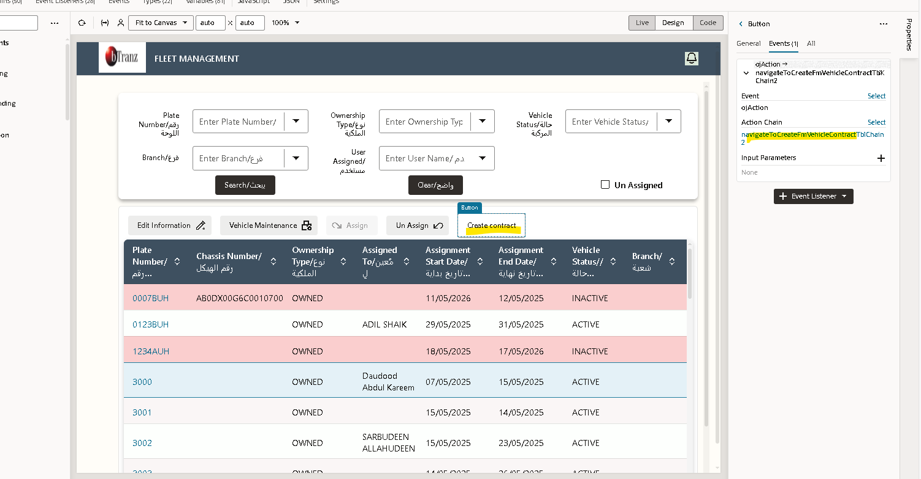
Go to the events of create contract page button
This event is triggered when a user performs an action (like clicking the Create Contract button).
It is responsible for navigating the user to the Create Vehicle Contract page in the Fleet Management module.
Step – Navigate to Create Page
navigateToPageMainCreateFmVehicleContractTbl2Result =
Navigate To Page main-create-fm-vehicle-contract-tbl2
- This single step uses the “Navigate To Page” action.
- When triggered, it redirects the user to the Create Vehicle Contract page —
main-create-fm-vehicle-contract-tbl2.
- This page allows users to enter new contract details for a selected vehicle.

Create Vehicle Contract Event
This event handles the navigation to the Create Vehicle Contract page in the Fleet Management module.
Action Flow:
- Executes a Navigate To Page action that redirects the user to
main-create-fm-vehicle-contract-tbl2.
- Used when the user clicks the Create Contract button to initiate a new contract entry.
Purpose:
To take the user from the current page to the Create Contract page where new vehicle contract details can be entered.

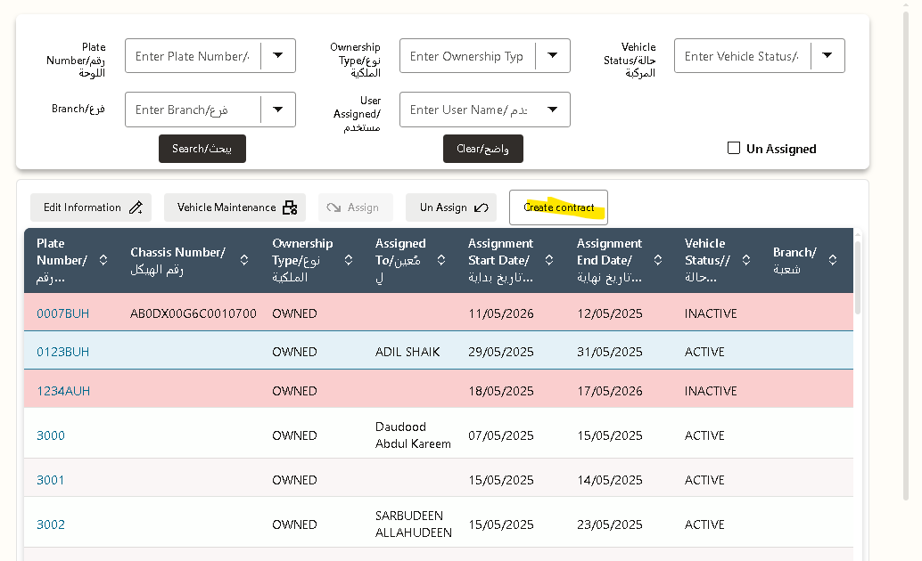

From this page you can create the new vehicle contract
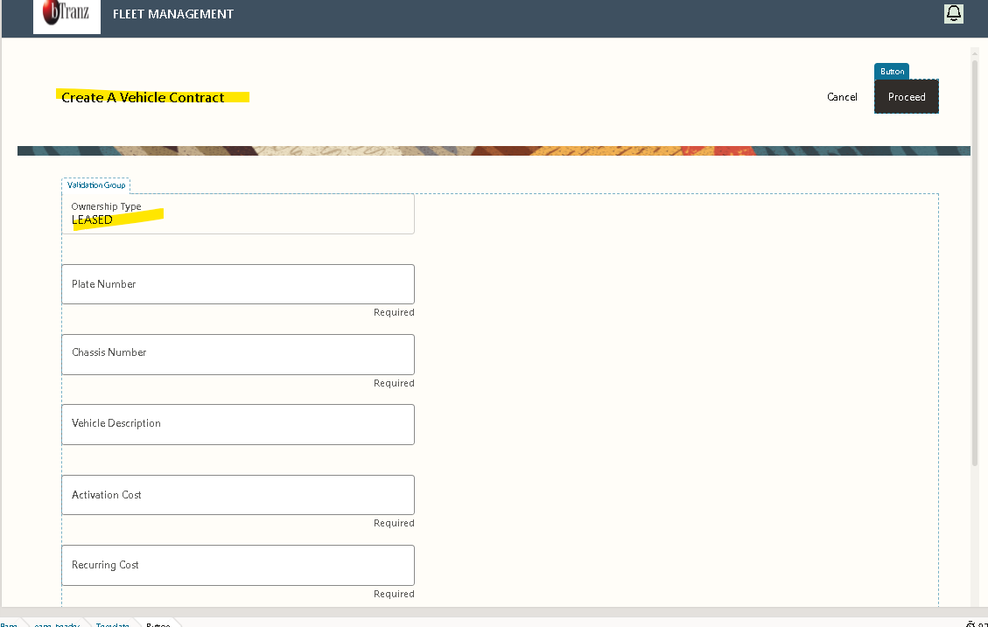
After giving the related information in the fields
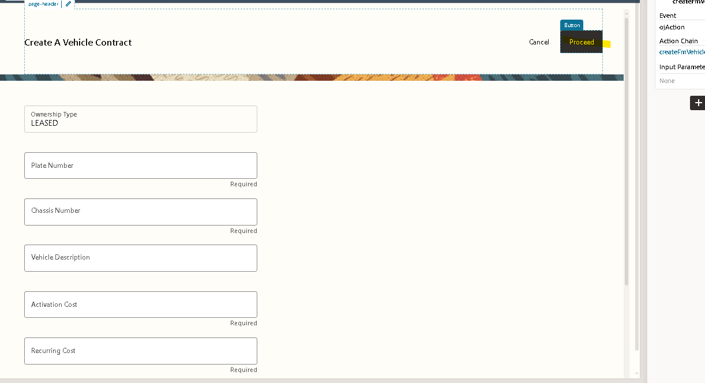
Click on the Proceed
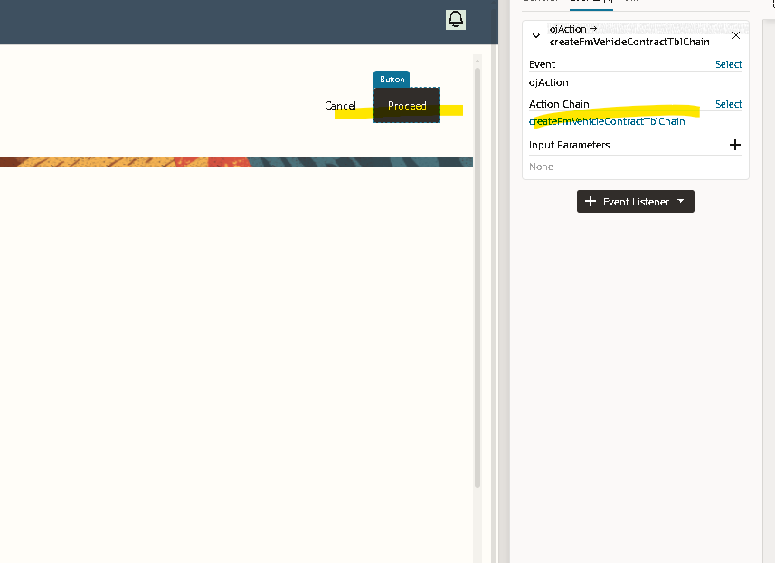
Create the Action chain
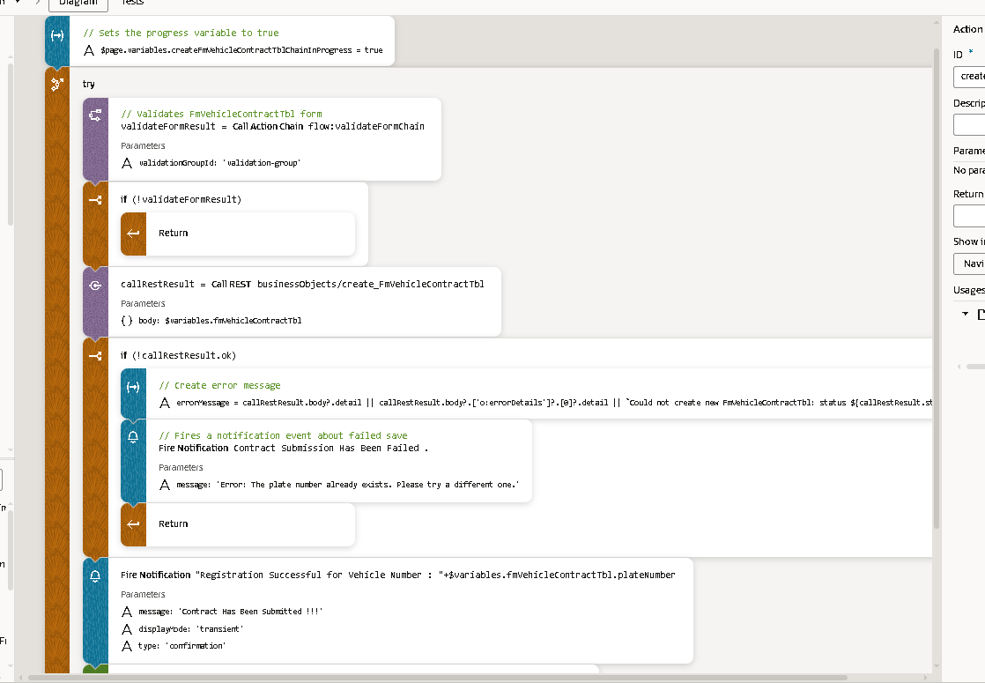
1.Set Progress Variable

Action:

$page.variables.createFmVehicleContractTblChainInProgress = true

Description:
This step sets a progress/loading flag to true so that the UI can show a spinner or disable the submit button while the chain executes.

Purpose:
Indicates that the contract creation process is in progress and prevents multiple submissions.

2. Validate Form

Action:

validateFormResult = await Actions.callChain(context, {
chain: 'flow:validateFormChain',
params: { validationGroupId: 'validation-group' }
})

Description:
This step calls the validateFormChain to ensure that all required fields in the Create Contract form are filled correctly.

Parameters Passed:

Parameter Value / Purpose
validationGroupId 'validation-group' → The ID for the validation group of form fields

Purpose:
Ensures the form data is valid before attempting to create a new vehicle contract.

Conditional Flow:

Validation Pass → Continue to REST API call

Validation Fail → Stop execution, reset progress flag

3. Call REST API to Create Contract

Action:

callRestResult = await Actions.callRest(context, {
endpoint: 'businessObjects/create_FmVehicleContractTbl',
body: $variables.fmVehicleContractTbl
})

Description:
This step triggers a REST API call to create a new vehicle contract record in the FmVehicleContractTbl business object.

Parameters Passed:

Parameter Value / Purpose
endpoint 'businessObjects/create_FmVehicleContractTbl' → Target API to create the contract
body $variables.fmVehicleContractTbl → Form data submitted by the user

Purpose:
Creates a new contract in the backend using the submitted vehicle information.

4. Error Handling for REST Call

Condition:

if (!callRestResult.ok)

Description:
Checks whether the REST API call executed successfully. If the call fails (e.g., duplicate plate number, network error), the chain executes error handling steps.

5. Create Error Message

Action:

errorMessage = callRestResult.body?.detail || callRestResult.body?.['o:errorDetails']?.[0]?.detail || `Could not create new FmVehicleContractTbl: status ${callRestResult.status}`

Description:
Generates a meaningful error message based on the REST API response.

Tries to extract detail from response.

If not available, uses o:errorDetails array.

If neither exists, uses a generic message with the HTTP status.

6. Fire Notification (Error Alert)

Action:

await Actions.fireNotificationEvent(context, {
summary: 'Contract Submission Has Been Failed .',
message: 'Error: The plate number already exists. Please try a different one.'
})

Description:
Displays an error notification to the user if the contract could not be created.

Example Messages:

"Error: The plate number already exists. Please try a different one."

"Could not create contract: status 400"

Purpose:
Alerts the user about the failure and stops further processing.

7. Return

Action:

return

Description:
Stops the execution of the chain if an error occurs.

Ensures no invalid or partial data is processed.

8. Fire Notification (Success)

Action:

await Actions.fireNotificationEvent(context, {
summary: "Registration Successful for Vehicle Number : "+$variables.fmVehicleContractTbl.plateNumber,
message: 'Contract Has Been Submitted !!!',
displayMode: 'transient',
type: 'confirmation'
})

Description:
Displays a success notification confirming that the vehicle contract has been successfully created.

Purpose:
Informs the user that the contract submission is complete.

Example Message:

"Registration Successful for Vehicle Number : ABC123"

9. Navigate to Main Edit Vehicle Information Page

Action:

await Actions.navigateToPage(context, {
page: 'main-edit-fm-vehicle-information-tbl',
params: {
fmVehicleInformationTblId: $variables.fmVehicleContractTbl.plateNumber
}
})

Description:
Redirects the user to the Edit Vehicle Information page to continue managing the newly created vehicle.

Parameters Passed:

Parameter Value / Purpose
page 'main-edit-fm-vehicle-information-tbl' → Target edit page
fmVehicleInformationTblId Vehicle plate number of the newly created record

Purpose:
Allows the user to immediately view or edit the contract details after creation.

🔟 Reset Progress Variable

Action:

$page.variables.createFmVehicleContractTblChainInProgress = false

Description:
Resets the loading/progress flag to false, removing the spinner and re-enabling the buttons on the page.

Purpose:
Ensures the UI returns to its normal state regardless of success or failure.

11. Summary of Flow
Step Action Purpose
1 Set Progress Variable Indicate the chain is running
2 Validate Form Ensure form data is correct
3 Call REST API Create vehicle contract in backend
4 Check REST API Response Determine success or failure
5 Create Error Message Prepare message if API call fails
6 Fire Error Notification Inform user about failure
7 Return Stop chain execution on error
8 Fire Success Notification Inform user about successful creation
9 Navigate to Edit Page Allow user to view/edit created vehicle
10 Reset Progress Variable Remove spinner and re-enable UI

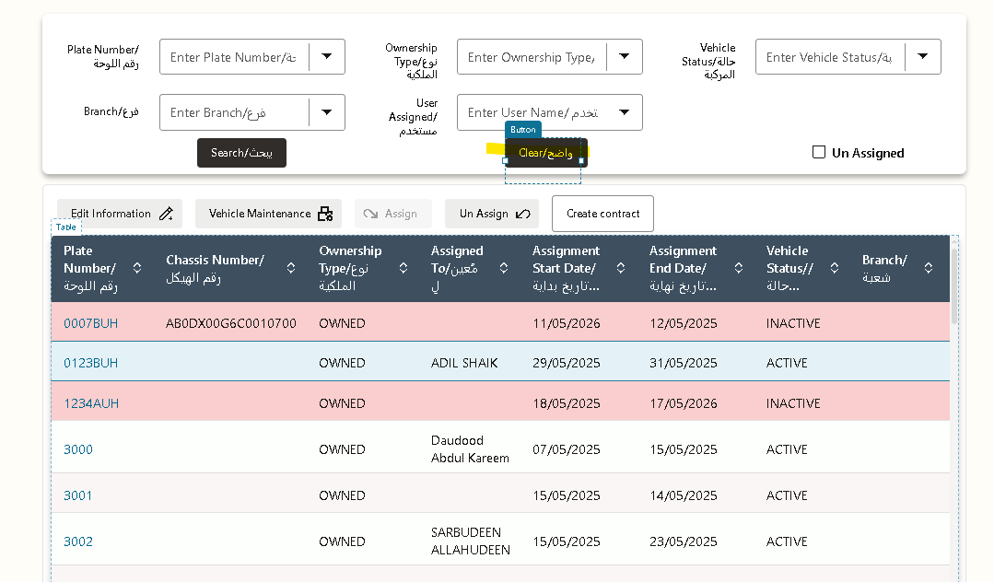
Reset Input Variables (Vehicle Filters)
Action:
await Actions.resetVariables(context, {
variables: [
'$page.variables.OwnerShip_Input_Var',
'$page.variables.PlateNumber_Input_Var',
'$page.variables.VehicleStatus_Input_Var',
'$page.variables.AssignmentStatus_Input_Var',
'$page.variables.Branch_Input_Var',
'$page.variables.ass_status_checkbox',
],
});
Description:
This step resets all the vehicle-related input fields on the page to their default state.
Purpose:
- Clears any previous user inputs in the vehicle search or filter section.
- Ensures the form is ready for a new search or assignment operation.
Variables Reset:
Variable | Purpose
OwnerShip_Input_Var | Vehicle ownership filter
PlateNumber_Input_Var | Vehicle plate number input
VehicleStatus_Input_Var | Vehicle status selection
AssignmentStatus_Input_Var | Vehicle assignment status selection
Branch_Input_Var | Branch filters
ass_status_checkbox | Checkbox for assignment status

2.Reset Employee Input Variable
Action:
await Actions.resetVariables(context, {
variables: ['$page.variables.userName_Input_Var']
});
Description:
Resets the employee search input field.
Purpose:
- Clears the employee name input in case a previous search was done.
- Ensures the user can start a new search without leftover data.

3.Reset Selected Employee Variable
Action:
await Actions.resetVariables(context, {
variables: ['$page.variables.selected_employee']
});
Description:
Clears the selected employee variable.
Purpose:
- Removes any previously selected employee from the assignment/unassignment process.
- Ensures the system does not assign actions to a previously selected employee by mistake.

4.Refresh Vehicle Data Provider
Action:
await Actions.fireDataProviderEvent(context, {
target: $variables.GetVehicleInformation_Var_ADP,
refresh: null,
});
Description:
Refreshes the Active Data Provider (ADP) that fetches vehicle information.
Purpose:
- Ensures the vehicle table displays up-to-date data.
- Clears previous data or selections in the table.

5. Reset Vehicle ADP Variable
Action:
await Actions.resetVariables(context, {
variables: ['$page.variables.GetVehicleInformation_Var_ADP']
});
Description:
Resets the ADP variable that stores the vehicle information.
Purpose:
- Clears any previously loaded vehicle data from memory.
- Prepares the page for a fresh query or search.

6.Reset Assignment/Unassignment Variables
Action:
await Actions.resetVariables(context, {
variables: [
'$page.variables.ass_purpose',
'$page.variables.Uassign_var_usertb',
'$page.variables.UnAssign_Var_New',
'$page.variables.Assign_Var_New',
'$page.variables.UnAssignBoolean_Var',
],
});
Description:
Resets all variables related to vehicle assignment and unassignment.
Purpose:
- Clears any previous selections or actions regarding assignment/unassignment.
- Ensures no leftover data affects new operations.
Variables Reset:
Variable | Purpose
ass_purpose | Purpose of assignment
Uassign_var_usertb | Unassignment user table variable
UnAssign_Var_New | Unassignment selection
Assign_Var_New | Assignment selection
UnAssignBoolean_Var | Boolean flag for unassignment

7.Summary of Flow
Step | Action | Purpose
1 | Reset Vehicle Input Variables | Clear all vehicle search/filter inputs
2 | Reset Employee Input | Clear employee search input
3 | Reset Selected Employee | Clear previously selected employee
4 | Refresh Vehicle ADP | Fetch latest vehicle data
5 | Reset Vehicle ADP Variable | Clear old vehicle data from memory
6 | Reset Assignment/Unassignment Variables | Clear previous assignment selections and flags

Un assign check Box
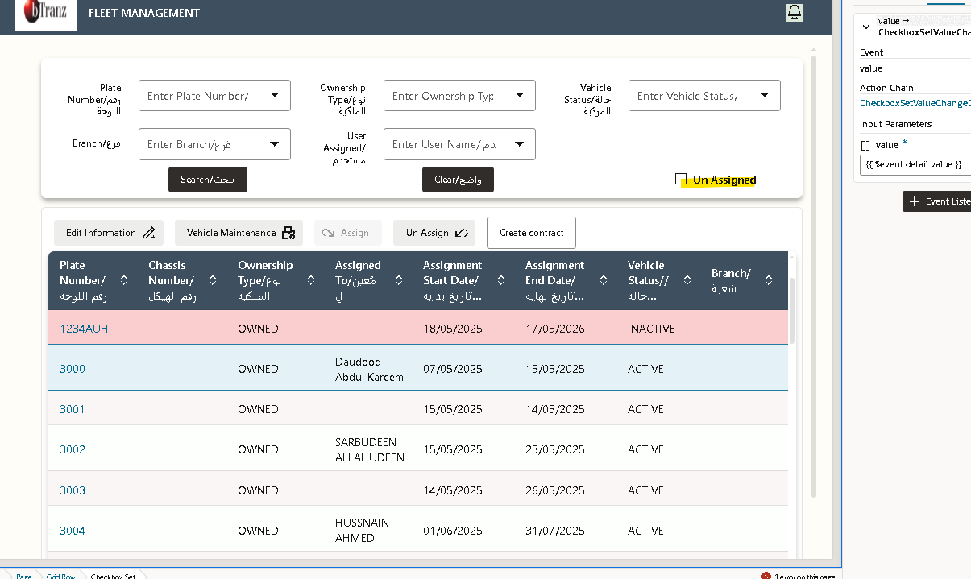

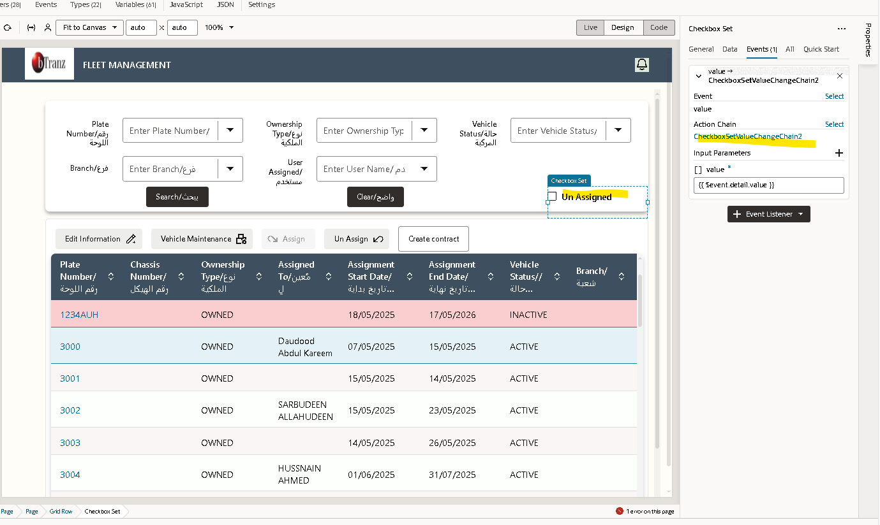
This event is triggered when the user performs the “Unassign” action on the Fleet Management page.
Its main function is to capture the value of the selected assignment status (from the checkbox) and store it in a separate variable that represents the unassigned checkbox state.
• Step 1 – Assigning Checkbox Value
$variables.ass_status_checkbox[0] = value[0]
- This line stores the first checkbox value selected by the user into the variable $variables.ass_status_checkbox[0].
- Essentially, it captures whether the first checkbox (related to asset status) is checked or unchecked.
• Step 2 – Mapping Value to Unassign Variable
$variables.unassign_check_box = $variables.ass_status_checkbox[0]
- This line then assigns that captured value to a new variable called $variables.unassign_check_box.
- This variable specifically represents the Unassign action’s status (checked/unchecked).
This event handles the logic for unassigning a vehicle or asset in the Fleet Management module.
- When the user selects a record using the assignment status checkbox and triggers the Unassign action, the event captures the selected checkbox value and stores it into an internal variable.
- The variable $variables.ass_status_checkbox[0] holds the status of the first selected record, which is then passed to $variables.unassign_check_box.
- This value is later used by subsequent action chains or logic to process the unassignment of the selected vehicle or asset.
Action Flow:
- Capture checkbox value into $variables.ass_status_checkbox[0].
- Map the captured value to $variables.unassign_check_box.
- Use this variable for further logic execution (e.g., update record status, refresh table, or call integration).

Renew Contract Page
The Renew Contract Page allows users to extend the validity of an existing vehicle contract in the Fleet Management system. It helps manage contract lifecycle by creating a renewed version of the previous contract with updated details such as new contract period, revised terms, or extended vehicle usage.

Purpose
To renew an existing fleet contract when the current contract is nearing its expiration or requires an extension.

Key Features

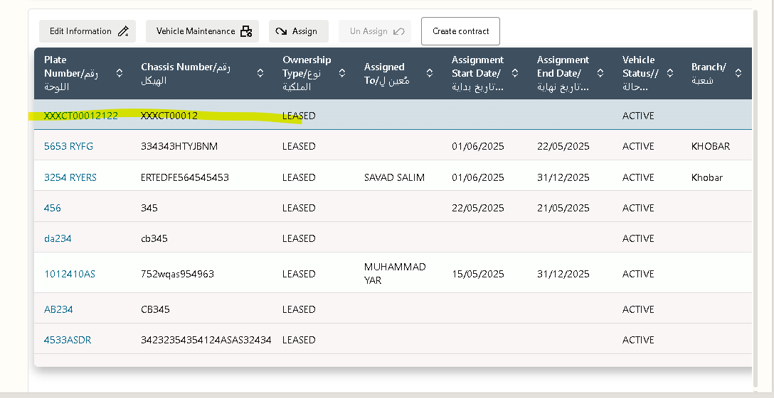
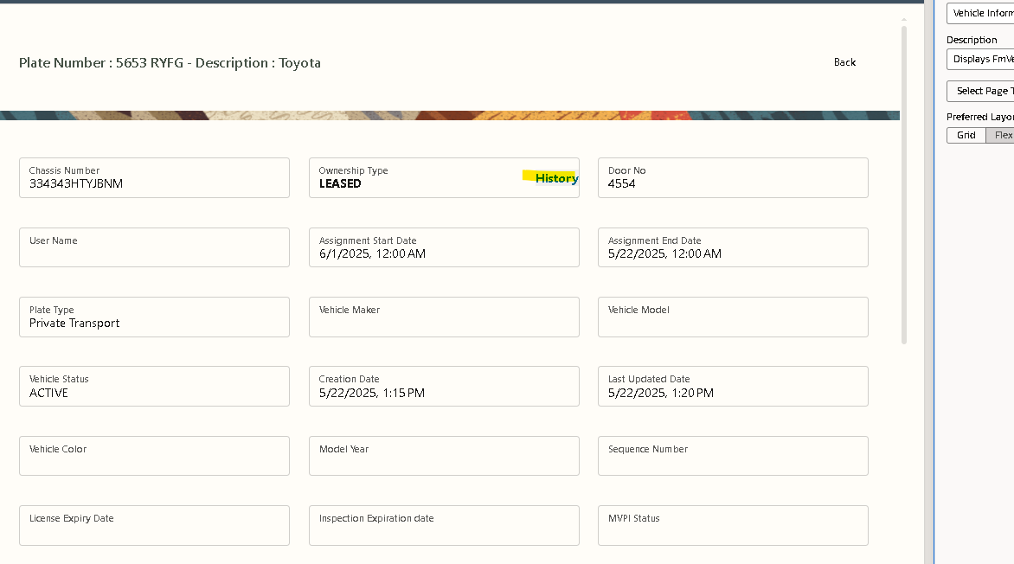
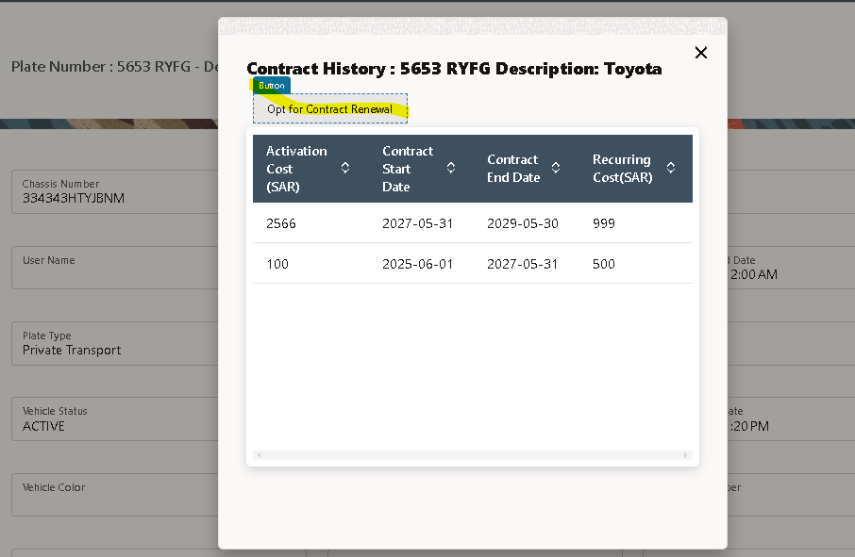
Create a button for contract renewal
Click on the pot for contract renewal

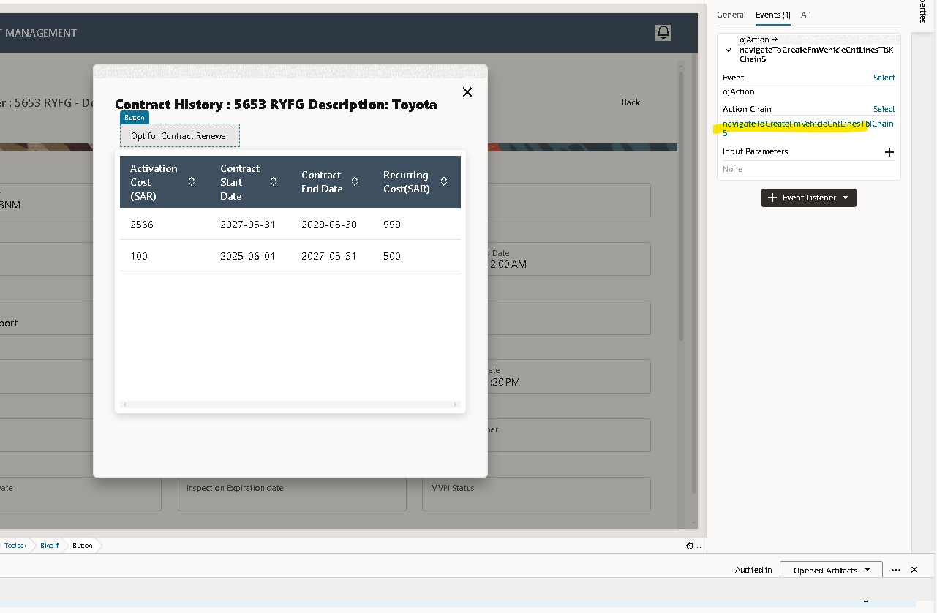
Click on events
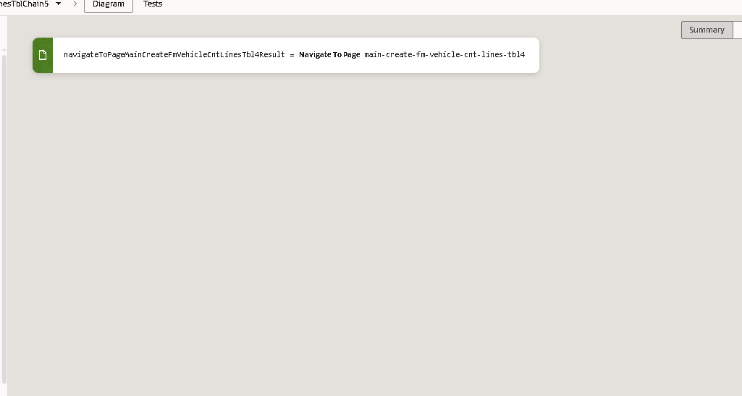
Here we are using the navigate to the page >navigate to the page of create

